Programing Assignment 1

**Problem 1:**

Considers the equation $px^{2}+qx+r=0$ and then gives the roots, based off any given *p, q,* and r. Some results are given in the table below.

|  |  |
| --- | --- |
| *q, p, r* | Result |
| 1, 2, 1 | There is one root -1 |
| 3, 4, 5 | The roots are imaginary |
| 2, 6, 2 | There are two real roots  -0.3819660112501051, -2.618033988749895 |
| 1, 3, 2 | There are two real roots  -1.0, -2.0 |
| 1, -7, 10 | There are two real roots  5.0, 2.0 |

**Problem 2:**

Analysis how the decay constant changes the overall equation $N\left(t\right)=N_{0}e^{-λt}$ this results in the graph

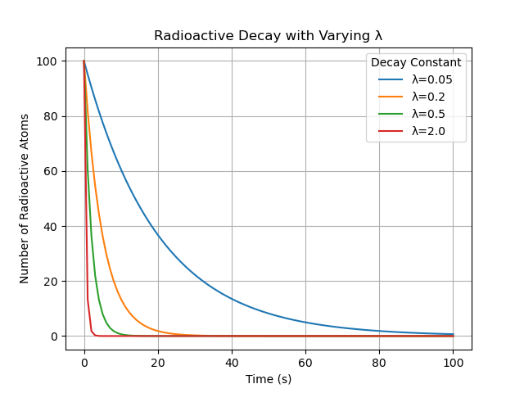

**Problem 3:**

Generates a random list of 20 numbers and puts in in descending order. Then calculates the mean, median, and mode for each of the list of random numbers.

**Problem 4:**

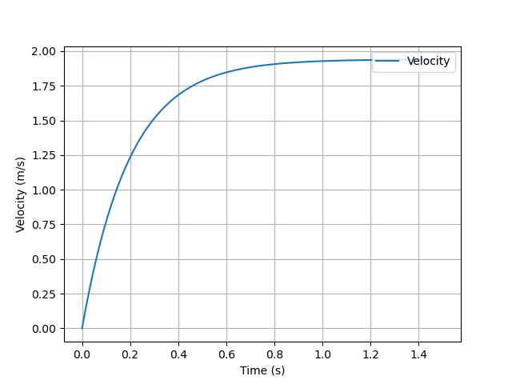a)

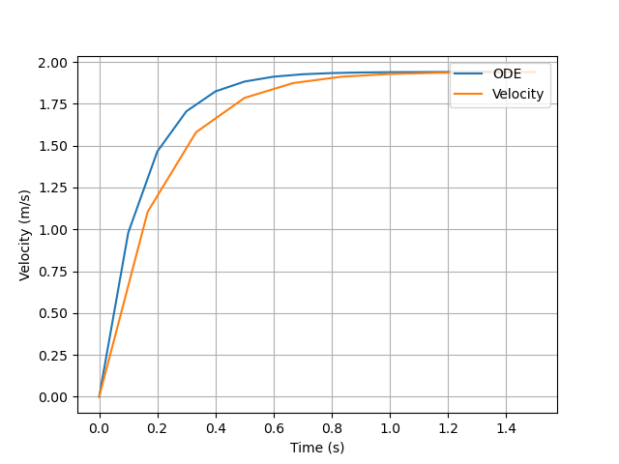b)

d)

When the mass changes to 98 kg the line looks to become a little bit more linear

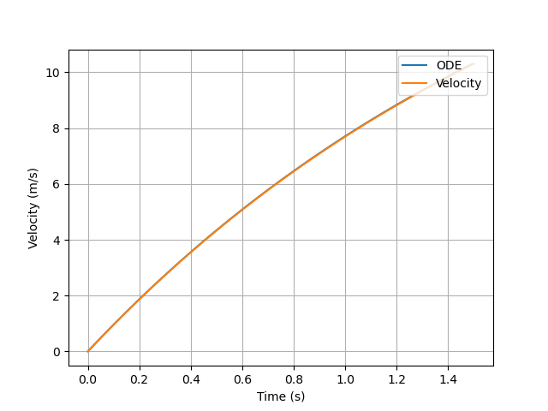

e) Theoretically the time required to attain 99.99 percent of the terminal velocity when the mass is 98 kg is

